**CNSL Lab Assignment 11**

**Neeti Kurulkar**

**Study and analyse the performance of HTTP, HTTPS, FTP protocol using Packet Tracer Tool.**

1. **Network Topology**

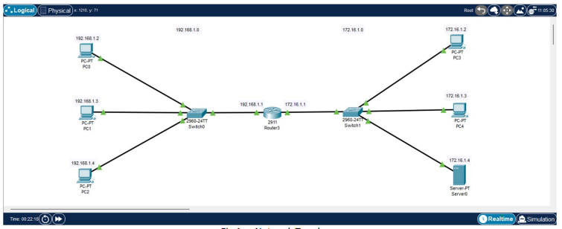

1. **IP Configurations of Server**

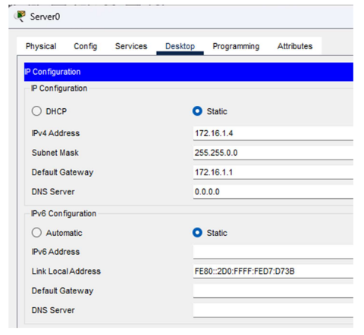

1. **Router Configurations** 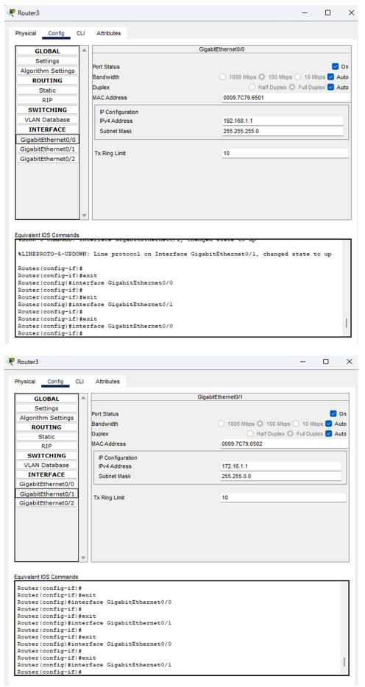
2. **Server FTP Service Fig**

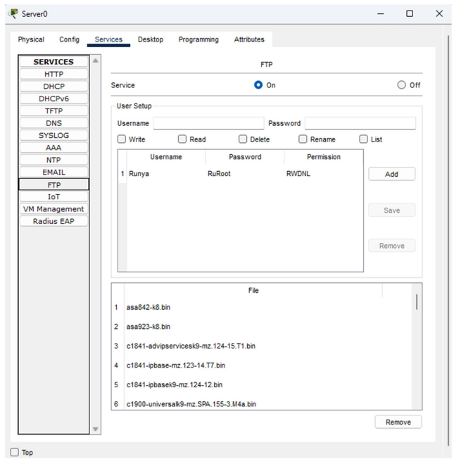

1. **Sending File from PC3 to Server**

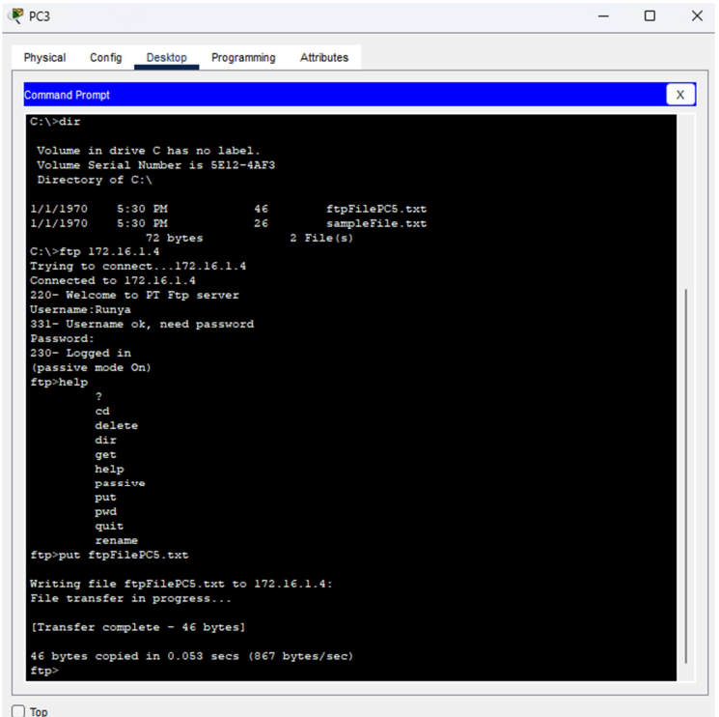

1. **Checking directory of Server for file sent from PC3.**

